INSTRUCTIONS FOR USING CASTOR – SOS UTI

Please follow the guide below to register cases on the Castor patient capture system. If there are any issues please contact one of the below:

Fergus Allerton (Willows) – fergus.allerton@willows.uk.net / 0121 712 7070

Andrew Kent (Willows) – andrew.kent@willows.uk.net / 0121 712 7070

You should already have received an email (see below) from Castor inviting you to register with the system – please follow the link and complete your details / set a password.

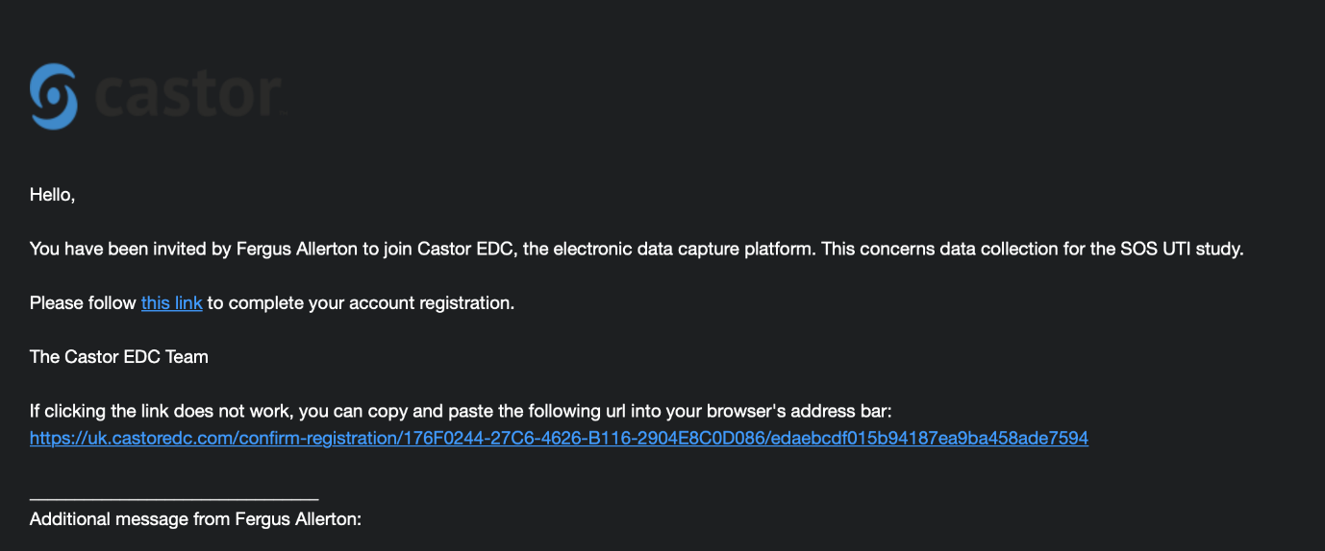

When you first log in to Castor you will see the screen below – please click on the SOS UTI trial to enter the study.

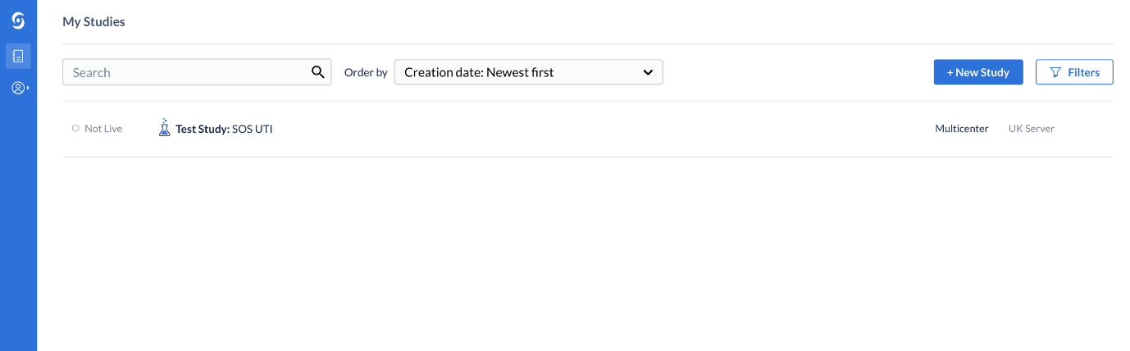

Once in the study you will see the below screen – when you wish to register a patient click on ‘+ New’

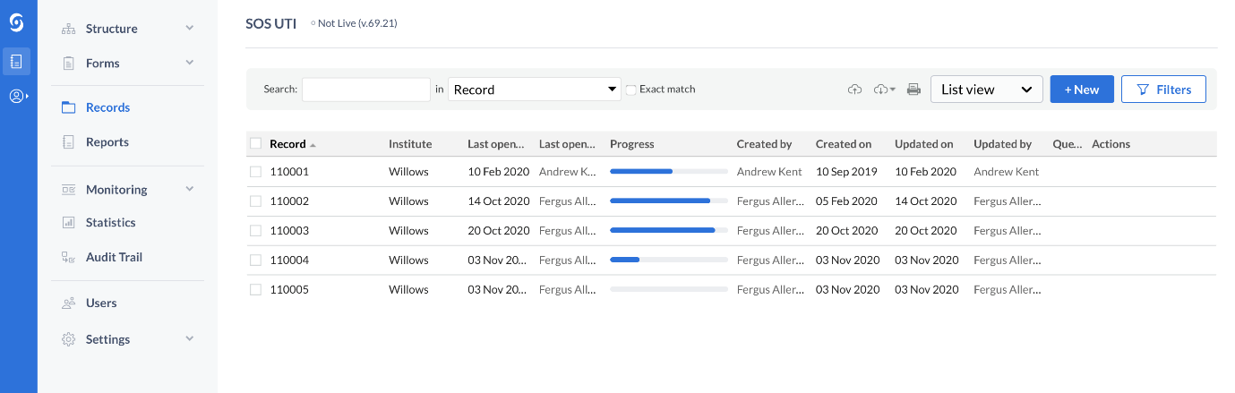

Select your institute from the drop-down box, the record ID will be populated by Castor.

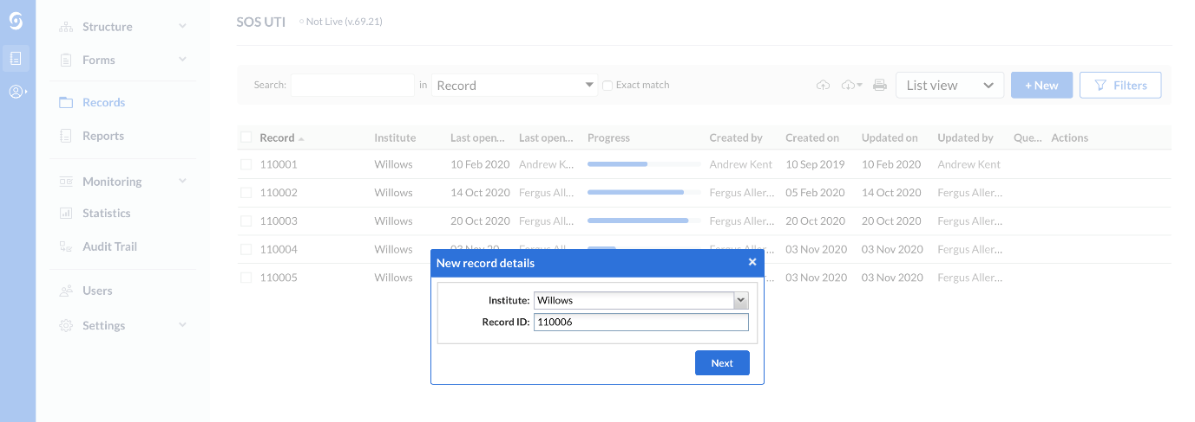

This will take you to the input windows – this should be self-explanatory and requires you to input the data requested (see below).

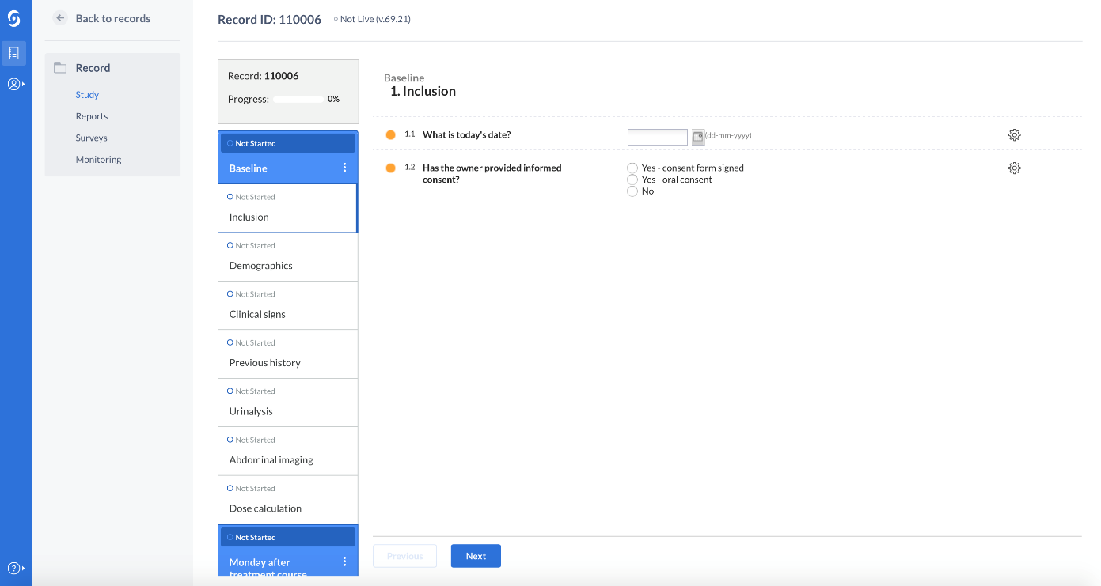

Once you have completed all the sections please click ‘Back to records’ to go back to the main screen where further patients can be registered.

Once the patient is registered it is vital we add the owner’s email address so that survey reminders can be sent, to do this please return to the main record screen and hover over and then click the settings cog under Actions and select Update email address:

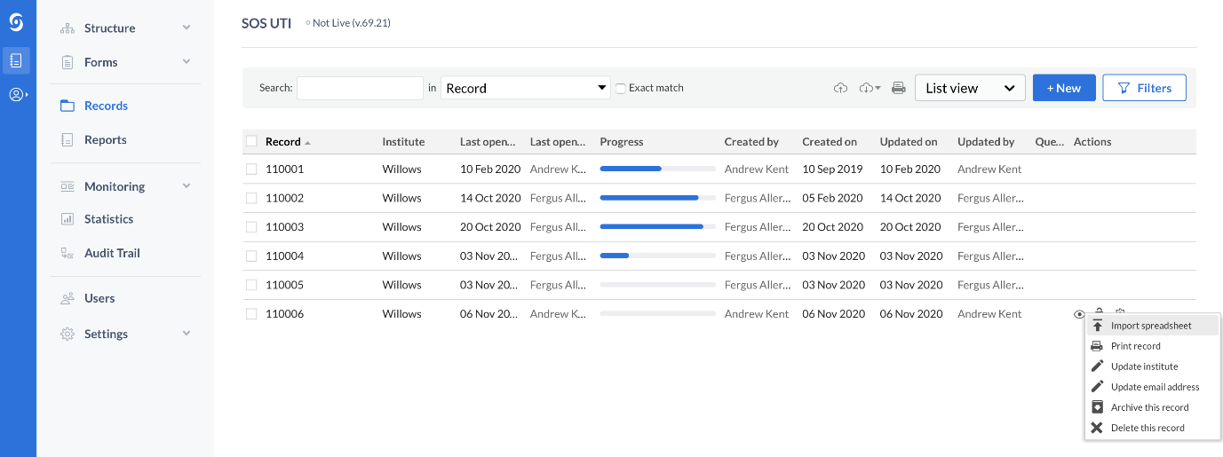

You will need to re-enter your password

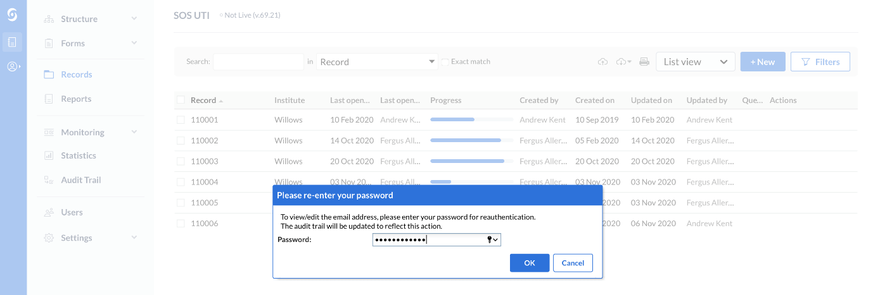

You can then input the owner’s email address – a reason for the change must be given to allow saving.
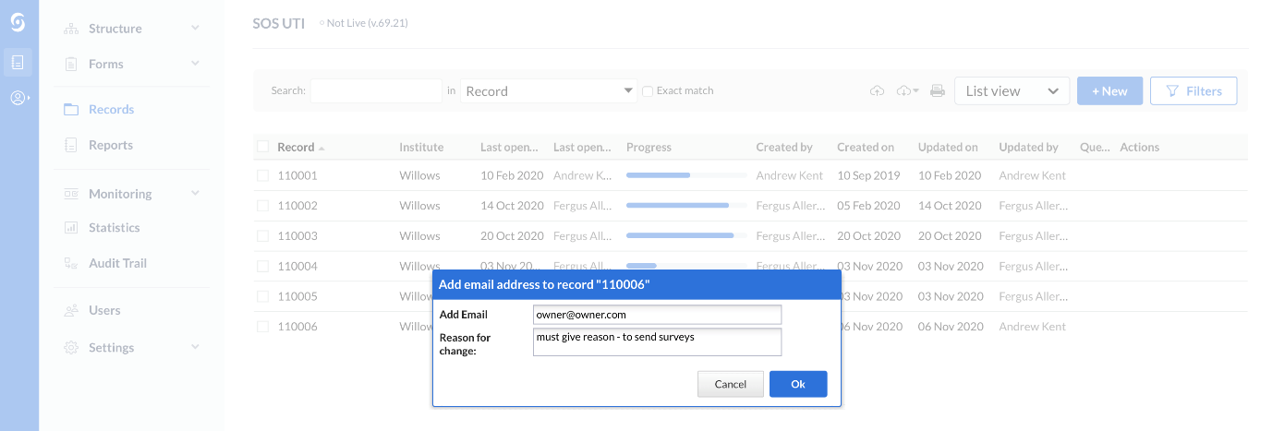
An additional report is required when an unexpected event occurs during the study period including:
- If imaging or additional urinalysis are performed after the initial presentation.
- If an adverse event occurs.
- If the patient is euthanased or dies.
- If there is an unscheduled visit during or after treatment.
When this happens please fill in a report on Castor. From the patient record click ‘Reports’ then ‘Add a report’

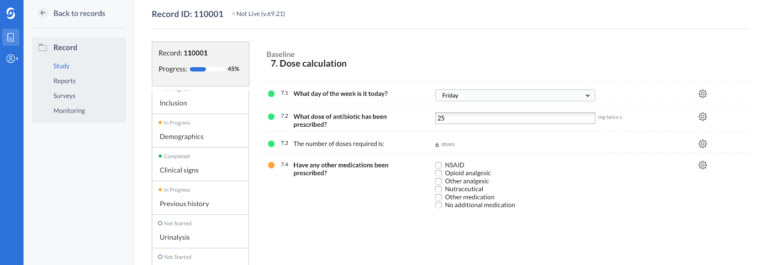

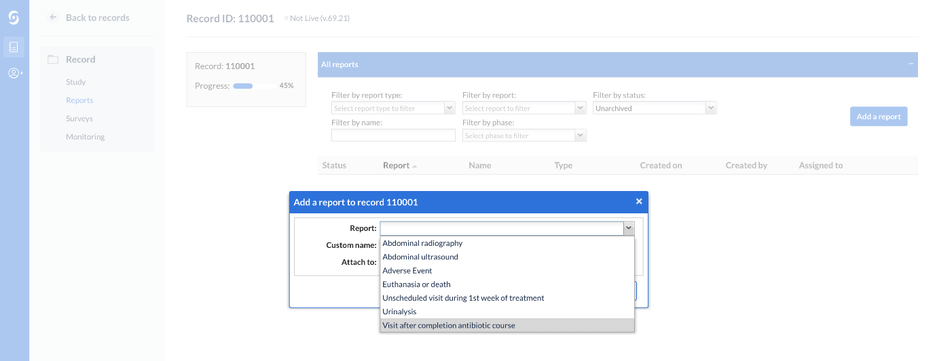

Please take the opportunity over the next few weeks to familiarise yourself with the Castor system and feedback any glitches, issues or suggestions before we go live in a few weeks.

Many thanks for your involvement with the project!

